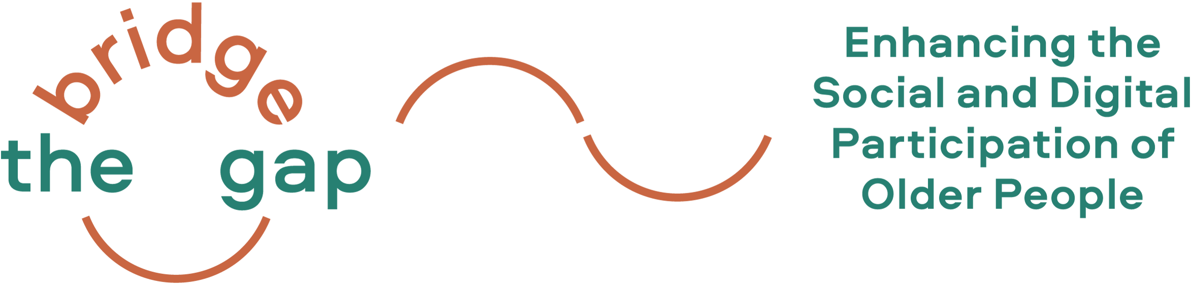

Welcome to the Bridge the Gap! Project

Two years of the Bridge the Gap! Project are now coming to an end…

With our Erasmus+ project Bridge the Gap! (realized from October 2020 until October 2022) we wanted to find creative and sustainable approaches to enable older people to live autonomously and to shape their living environments in a way that sustains independence as well as their social and digital participation.
We believe that older people can benefit most if they themselves actively change their environment according to their needs and preferences. Thus, the aim of our project Bridge the Gap! was to train and empower older people to implement their ideas for an age-friendly environment with the support of digital tools.
Thanks to all of our participants and cooperation partners, who have joined and supported us during our Bridge the Gap! journey.

Project News
Our Training Kit is now available!

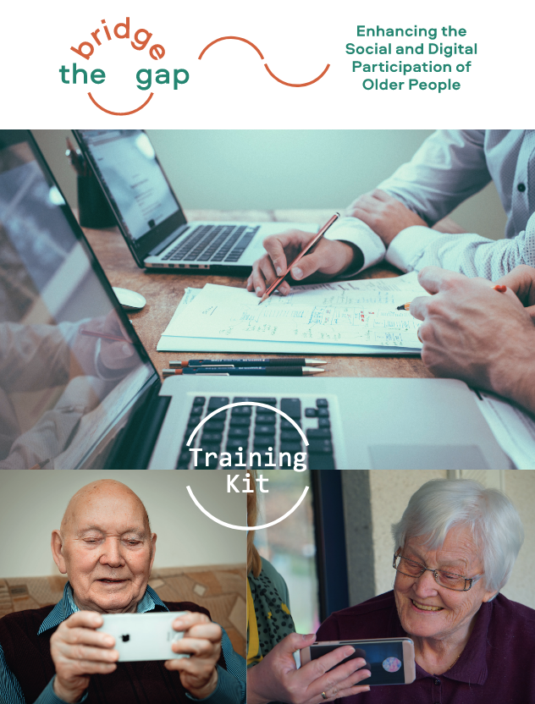
The Training Kit provides useful and practical training methods for trainers (including adult educators, community developers, volunteers in organisations working for/with older persons), as well as tips and tricks on how to support teamwork and foster mutual learning. Have a look here.

The Training Kit is available in English, Italian, German, Lithuanian and Dutch!

Bridge the Gap! final event September 2022

Thank you for participating in our Bridge the Gap! Final Online Event on September 27th! It was a pleasure to share and discuss our learnings and reflections. We are happy to share the documentation of the final event. Please find a link to the recordings of our presentations about the project and insights into the activities in all five Bridge the Gap! countries (Austria, Germany, The Netherlands, Italy, Lithuania).
Final step(s): Finalizing our Digital Training
The Digital Training is based on our manifold experiences and results of the Bridge the Gap! project! The online training provides you with three modules and at the end some practical information and links to further resources. The three modules are:
- Age-Friendly Environments
- Ageing in an increasingly digital era
- Let’s look at some practical tools supporting you to get active in your neighbourhood/city

You will find the Digital Training (in the coming weeks) as well as all other publications ( Factsheet, National Research Reports, Training Concept and Curriculum, Training Kit) elaborated in the project (available in English, Dutch, German, Italian and Lithuanian) on our website.

Let’s keep in touch!
If you are interested in activities in our partner countries, please contact the partner organisations. Please feel free to contact us if you require any further information or if you would like to share your experiences and ideas with us!

In terms of privacy policy …
We would like to continue to provide you with up-to-date information about our projects and are glad to do so if you continue to subscribe to our newsletter, however, we also remind you that you can unsubscribe from this distribution list at any moment by clicking on "unsubscribe from this list" (see below). Your personal data will then be deleted from our mailing list. If you wish to receive again Dreamlike Neighbourhood newsletter, you will need to subscribe again and enter your personal data on www.dreamlike-neighbourhood.eu. In short, we assure you that we handle your personal data with the utmost attention and care. If you want to know more about it, here you will find our privacy policy.

Best wishes,

The Bridge the Gap! partnership
The European Commission's support for the production of this publication does not constitute an endorsement of the contents, which reflect the views only of the authors, and the Commission cannot be held responsible for any use which may be made of the information contained therein.

