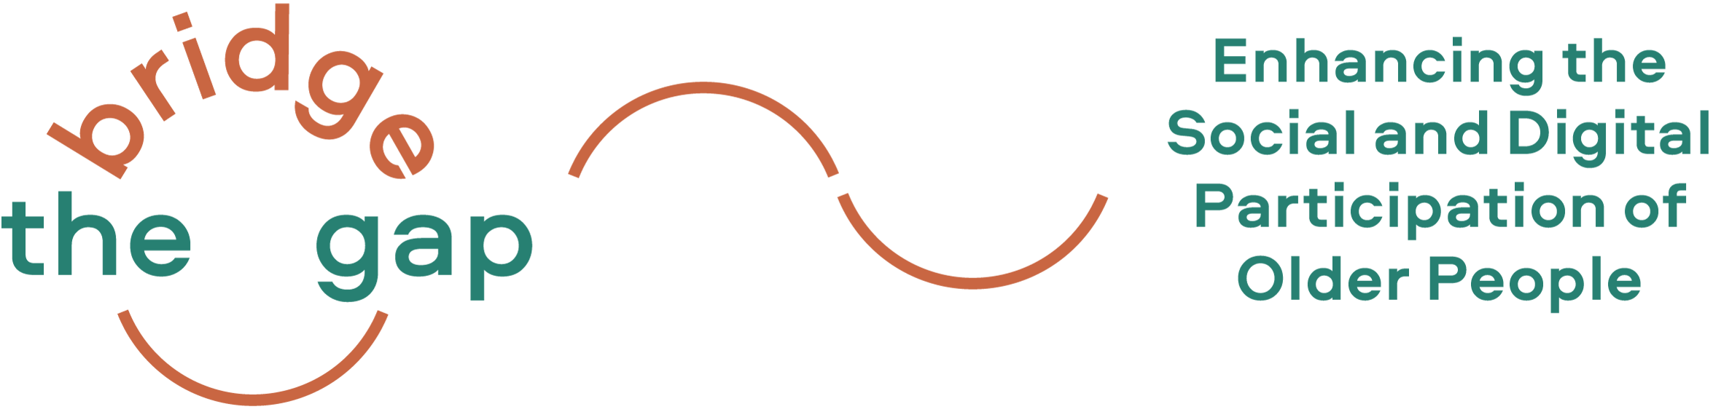

Welcome to the Bridge the Gap! Project

Our Vision

Older people as experts of their own life know best how services and public spaces should be designed and organised to meet their needs. They want their voices be heard, their experiences be acknowledged and their skills be actively used and valued. Meanwhile, social participation also increasingly encompasses digital participation, as digitalisation transforms almost every area of our society.
With our Erasmus+ project Bridge the Gap! (realized from October 2020 until September 2022) we want to find creative and sustainable ways to enable older people to live autonomously and to shape their living environments in such ways that they sustain independence as well as the social and digital participation of older citizens. With our project we want to support and train older people to explore, analyse and (re-)shape their neighbourhoods with the help of digital tools.

“We urgently need change and change may come from senior citizens: that’s why we need to upgrade their digital literacy.”
(Volunteer in the publishing sector, Italy)

“I like this project so much because it enables older adults to participate socially and become active, and it is often this group that is overlooked.”
(Expert interviewee, Mobility Agency Vienna, Austria)
Project News

Our Fact Sheet is now available!

The comprehensive changes that accompany digitalisation are visible in all areas of life.
What does this mean for the increasing number of older people in society? What role do digital media and the Internet play in the social participation of older citizens and what hurdles must they overcome?

These are some of the questions we are tackling in our fact sheet! All organisations involved in the Bridge the Gap! project have carried out desk research in their countries (Austria, Germany, Italy, Lithuania and the Netherlands) and conducted 56 interviews with experts, practitioners, stakeholders and older people who could potentially become active in the project.
Find the fact sheet in several languages and national reports here: https://bridgethegap-project.eu/ressources/

Bridge the Gap! website: get an easy access to all project information!
If you are interested in a regular update on project activities and outcomes, please have a look at the Bridge the Gap! Project website: https://bridgethegap-project.eu

Next step(s) – Stay tuned!

Developing the training concept and filling our curriculum with life!
We are currently co-developing a Training Concept and Curriculum with older citizens as a basis for the training series that will be conducted in all partner countries in the second half of 2021.
The training sessions aim to support older adults in developing their own ideas based on their interests and needs, building up strong teams and networks and implementing age-friendly neighbourhood initiatives.
If you are interested in activities in our partner countries, please get in contact with partner organisations.
Please feel free to contact us if you require any further information or if you wish to share your experiences and ideas!

In terms of privacy policy …
We would like to continue to provide you with up-to-date information about our projects and are glad to do so if you continue to subscribe to our newsletter, however, we also remind you that you can unsubscribe from this distribution list at any moment by clicking on "unsubscribe from this list" (see below). Your personal data will then be deleted from our mailing list. If you wish to receive again Dreamlike Neighbourhood newsletter, you will need to subscribe again and enter your personal data on www.dreamlike-neighbourhood.eu. In short, we assure you that we handle your personal data with the utmost attention and care. If you want to know more about it, here you will find our privacy policy.

Best wishes,

The Bridge the Gap! partnership

The European Commission's support for the production of this publication does not constitute an endorsement of the contents, which reflect the views only of the authors, and the Commission cannot be held responsible for any use which may be made of the information contained therein.
